Computer Network Lab Task
Name: Abubakkar Abdullah
Roll No: 20P-0045
Section: BSCS(5B)

Task: Sharing files between two pc’s using via LAN cable
First we connect both the PC’s with the LAN cable
First PC Set-up
Then we open Network and Internet and over there we go to Network and Sharing Center
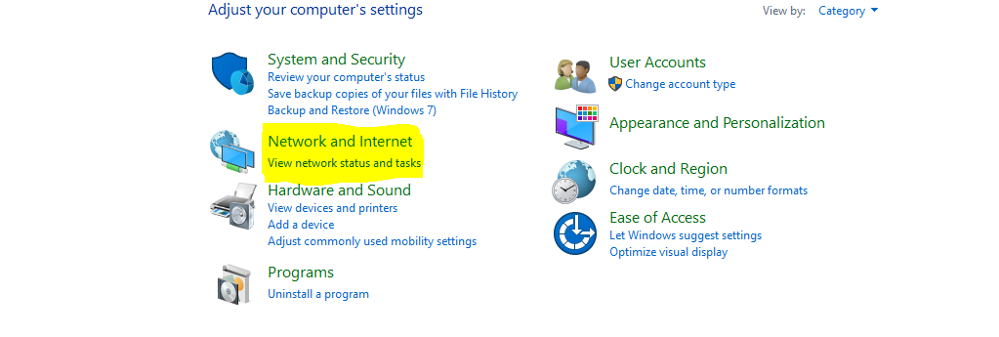
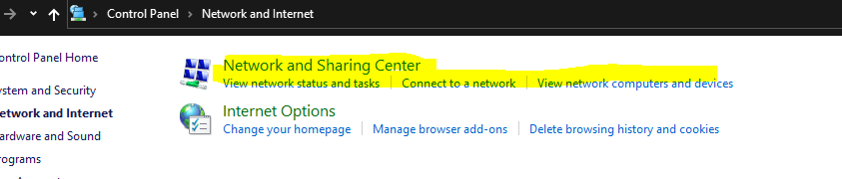

Then we go on change advanced sharing settings
And turn on sharing
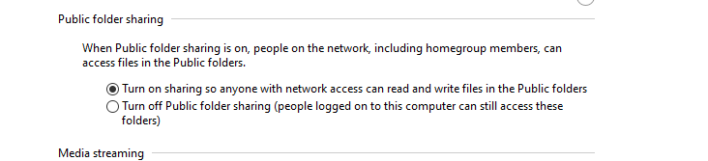
When we connect the both pc we get this interface
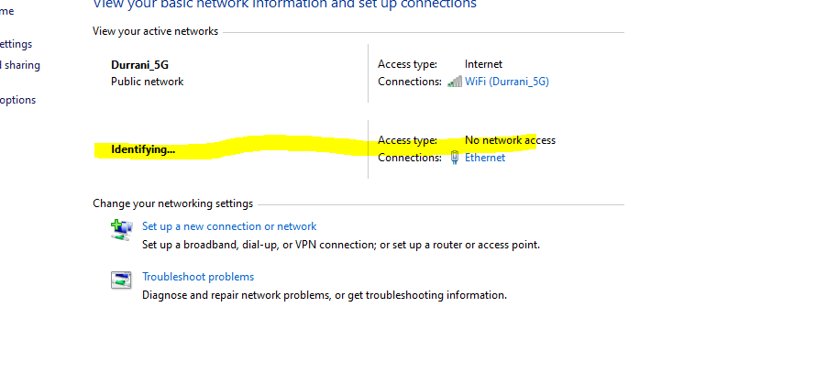
As we can see it is unidentified
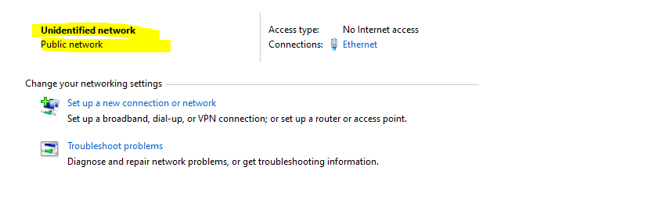
So IPV4 has no internet access
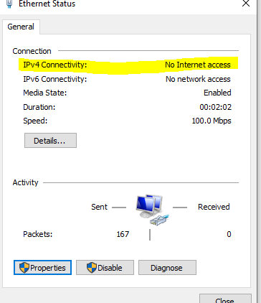
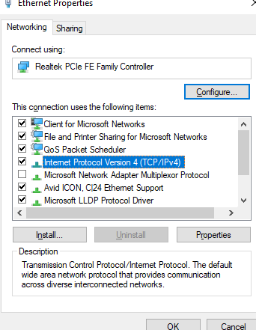
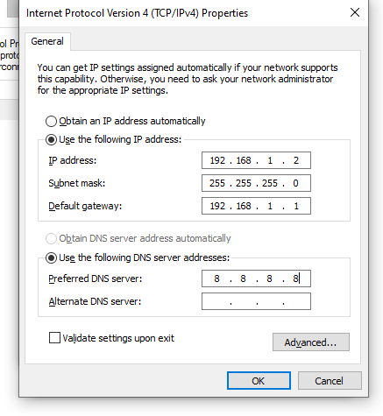
then click on ok and save
Then we go to Local Disk C and go to users and go to private folder and right click and go on give access to specific people and over there we add everyone and change permission level to read/write
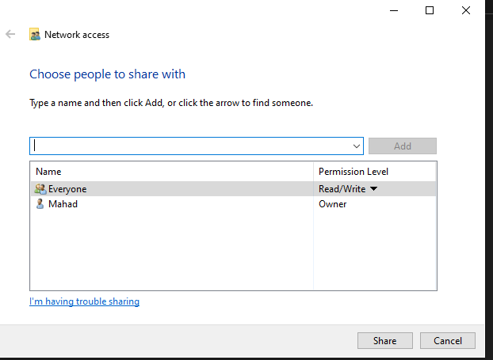

Second PC
We follow the same steps mentioned above but the difference is we change the IP address and default gateway

Now we open Network Folder and we can see two pc
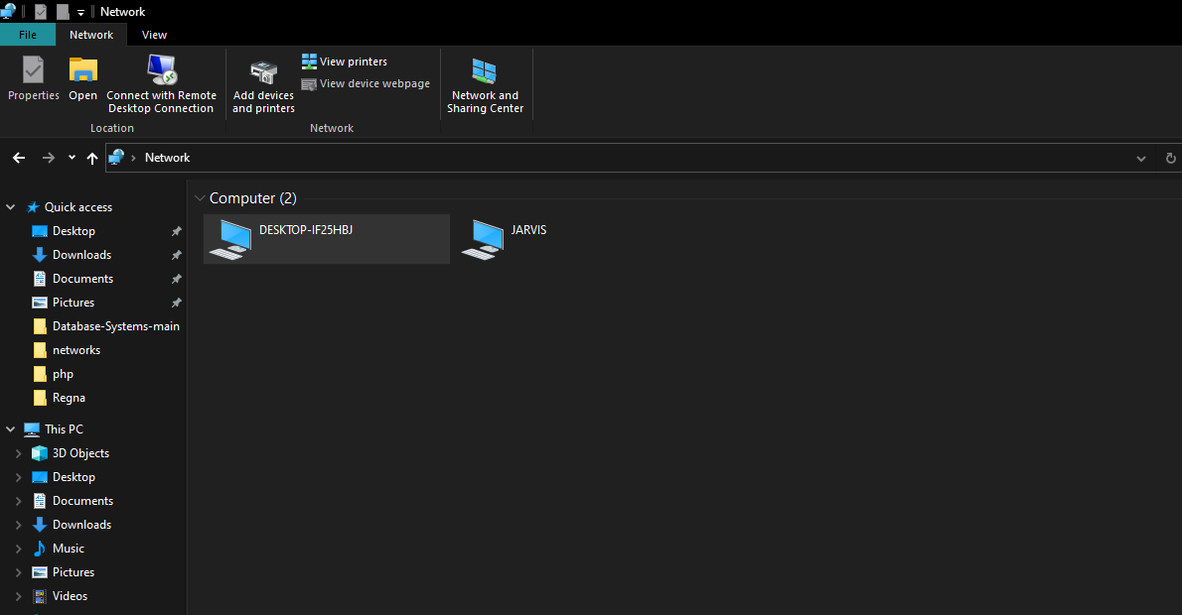
And when we open desktop we see the user name
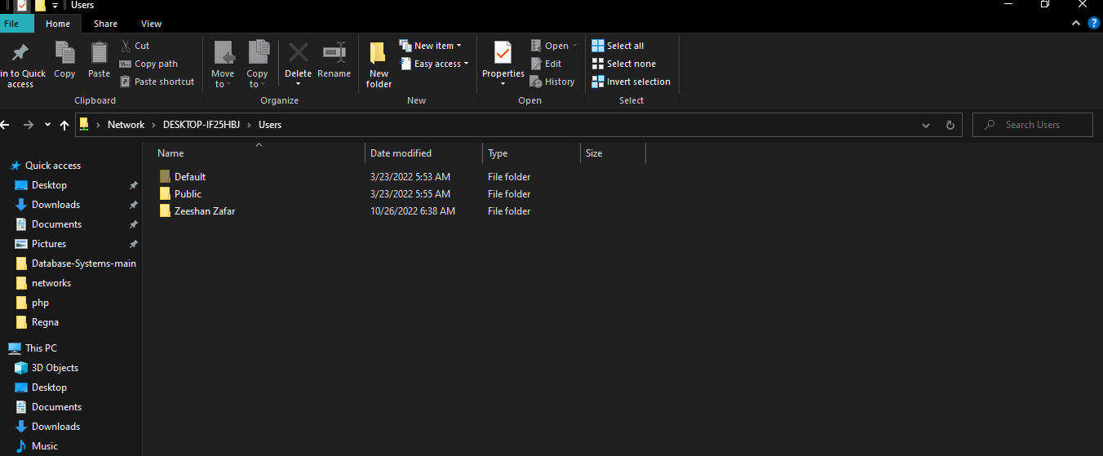

Now we can share files
So we go on pc 1 and go to accounts data folder and copy acc file
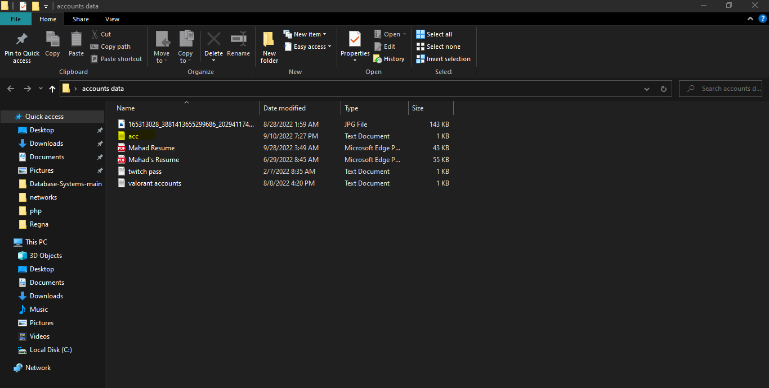
Then we go to networks and go to pc2 user and go second Desktop
And paste the file
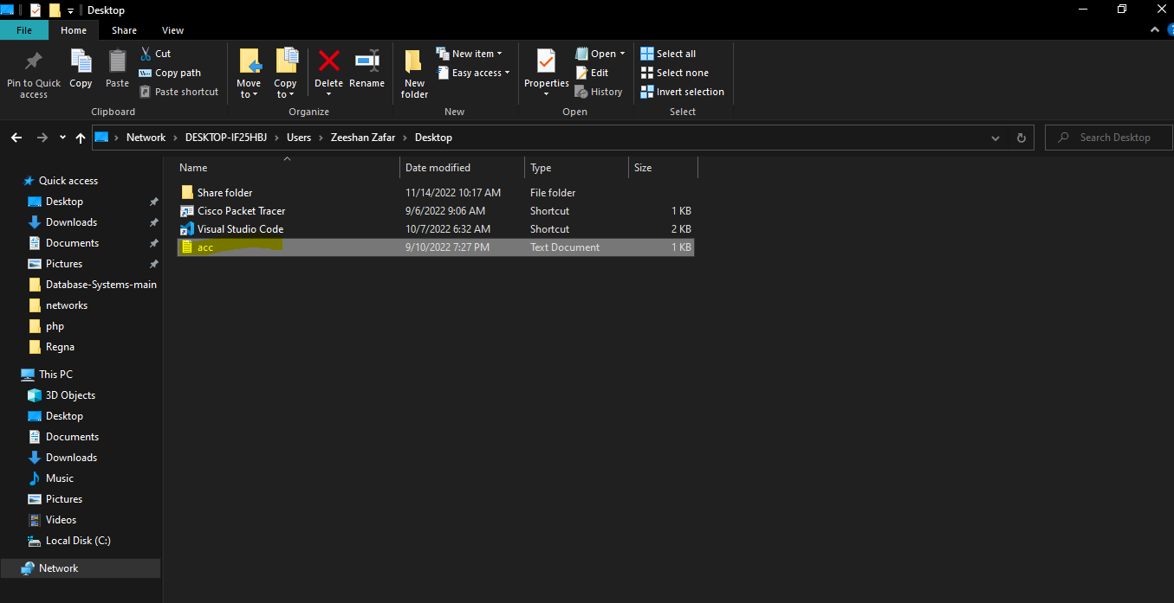

Second PC Desktop view
